Aim:

To create a Wayanad donation page

Procedure:

-First create a rough sketch of the design your going for in a

sheet

-After that create wire frames for your platform of choice

-After crating wire frames create the design

-Then give prototype to the design

-You have the final product

Screen shots:

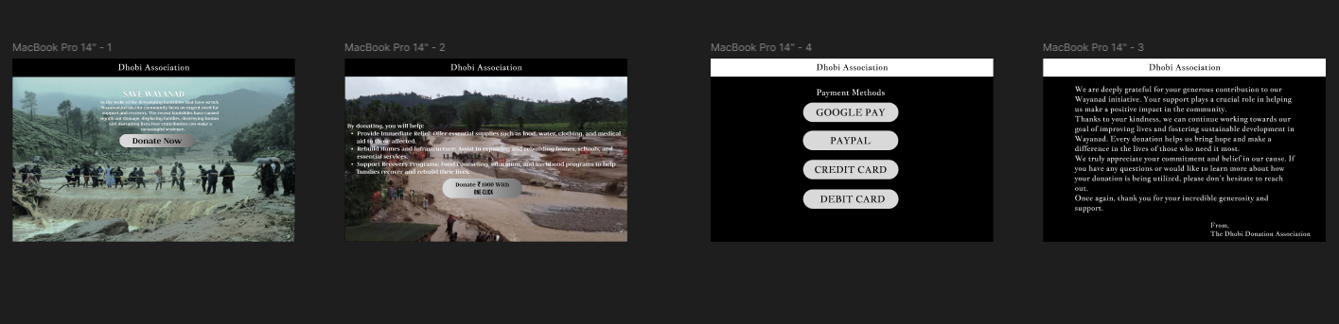

RESULT:

THE DESIGN HAS BEEN SUCCESSFULLY CREATED